**Power BI – Zomato Project Step By Step Summary**

1. Use 1st as column from option – In Transform Data Section
2. Loaded all the files
3. Using Power Query Editor Used Merge Queries option to Join the Orders and Restaurant Table on the basis on ID column and then selected only city column from restaurant table
4. Changed the restaurant.city name to city
5. In the city column replace the ‘nulls’ with ‘others’
6. Selecting the Sales Qty and Sales Amount column and making them Unpivot
7. We get the rows for Sales Qty and Sales Amount, replacing Sales Qty as Quantity and Sales Amount as Amount and changing the column name as Type
8. Applying the changes and closing the power query, Creating a new table measure_table
9. Creating a new measure in measure_table as Sale_Value = Sum(Order[Value])
10. Creating a Slicer Quantity and Amount
11. Created a bar chart for Sales_value and city
12. Created a new column year using Year = FORMAT(orders[order_date],"yyyy")
13. Created a Line chart using Sales value and year and sorted years to ascending
14. Creating KPI Cards for Quantity and Amount without having the connection to the slicer
15. Creating a New measure as ratings and connected the ratings with orders table
16. Creating a new column in Food table as Veg or Non_Veg and replacing there nulls as Others & then made a ratings KPI’s For each
17. Creating a Dynamic slicer for Top cities using the measures

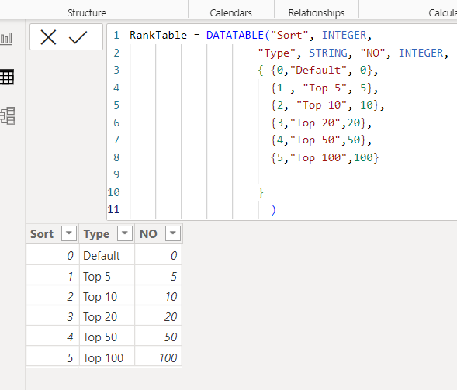

1. Added the Top N Slicers using the Below Query:

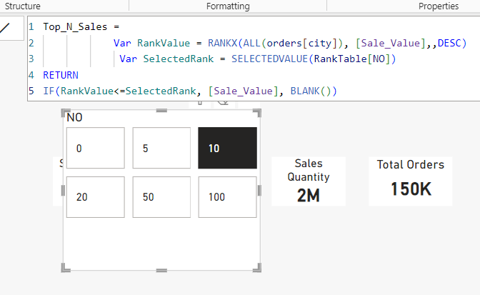

1. Title of chart changes w.r.t Slicer using below query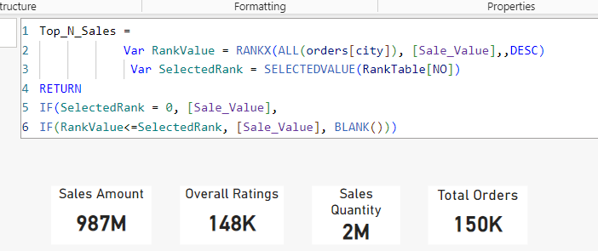
2. Created a logo and other small details to make a dashboard more attractive
3. Created a 02nd page for Users Overview
4. Created a bar chart for users w.r.t. to their age, it shows users from age 21 to 26 have high volume of orders
5. Created all the related KPI’s showing the user details
6. Created a new measure for Gain Customer using

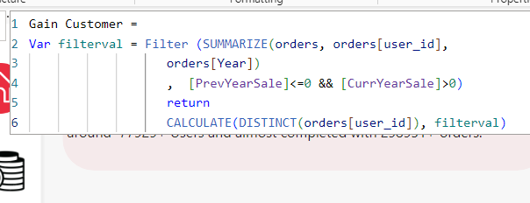

1. Got an text error while creating current year measure

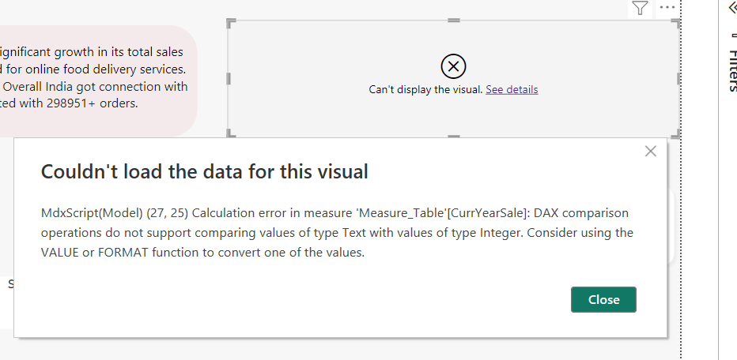

So to fix this the values of year was put into the “ 2020 ” and error was resolved

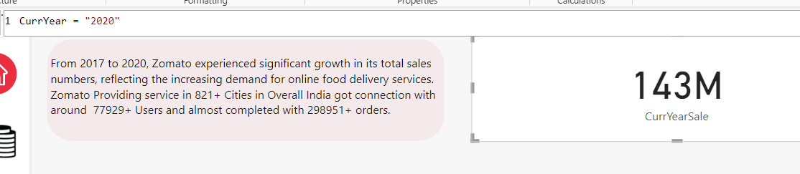

1. Created a City performance page and added the important parameters such as City Sales value, Active Users as per City
2. Created a table containing sales overview
3. Made an Index Page and created as Dashboard Button that guide us to overview page